Jake Tompkins

Tyler Bream

Basketball Shooter

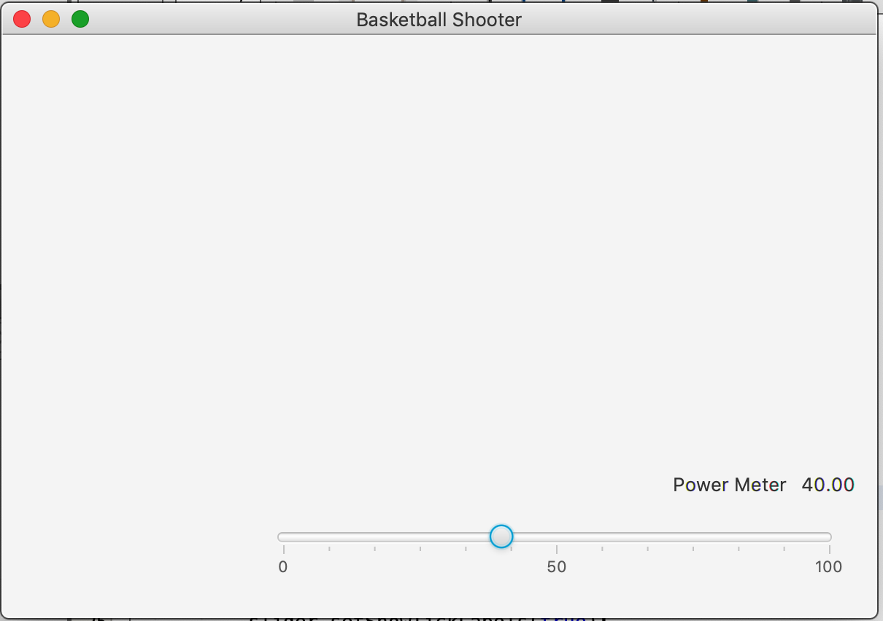 

We plan on implementing a ball into our deliverable. The ball will move across the screen based on the user input from the power bar. We will take the shot power from the calculateshotpower and getshotpower methods and implement it into the basketball mechanics that will make it move across the screen. The basketball will be created in the view class and the power will be taken from the viewer as user input which will then be communicated to the model by the controller. The model will calculate the shot power which will be sent to the viewer which will cause the ball to move based on user input. A shoot button (blue button) will be created to take the shot power and cause the ball to move.

We will test this functionality by seeing if the ball flies across the screen once the blue button is clicked by the user. We will also check that the changed shot power will change the shot of the ball.

Both team members will help each other and contribute to each functionality.